**Annie J Chaperone**

GitHub: https://github.com/AnnieJDesigns/chaperone-crowdfunding

Deployed App URL: <https://empty-silence-2325.fly.dev/>   
(Not working)  
Screenshots:

Home Page  
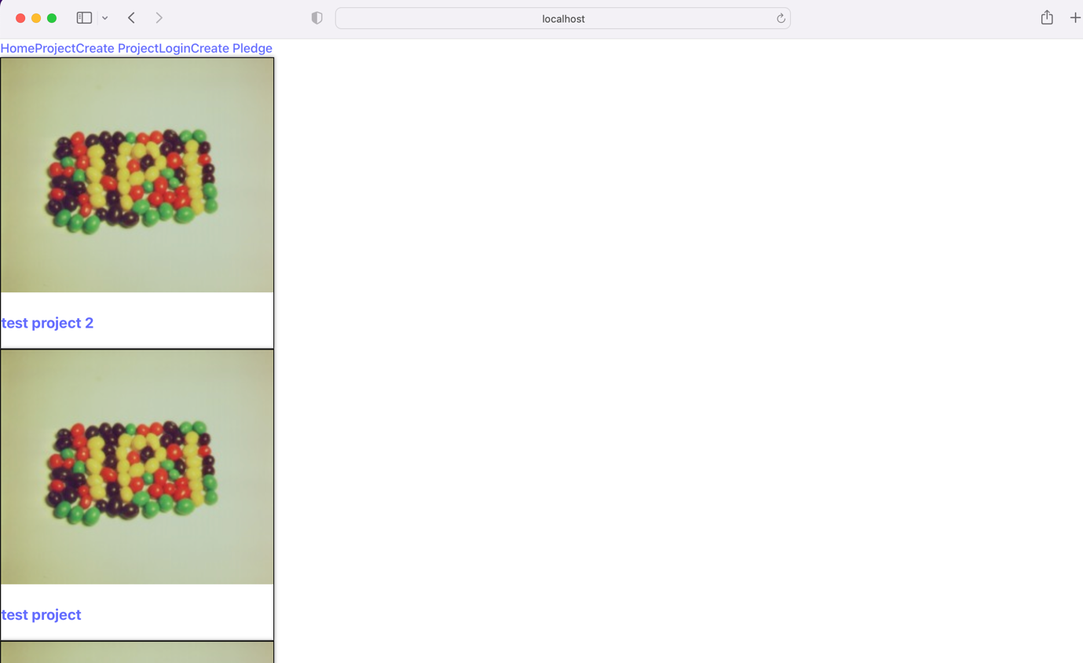

Project Page

Create Project Form

